

Computer Games Development

Project Report

Year IV

Alex O’Toole

C00216095

03/05/2020

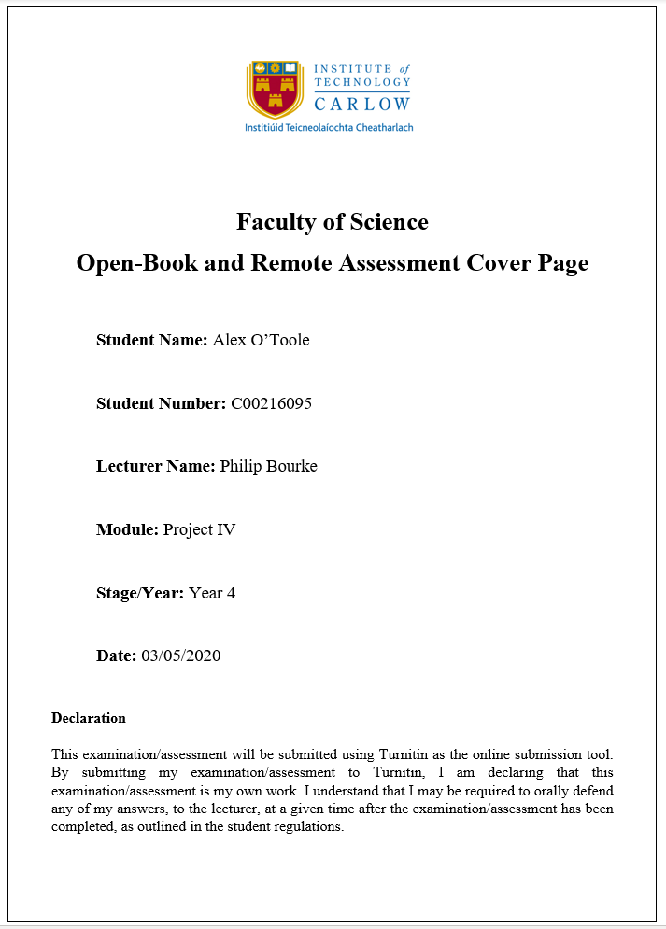

**Contents** **1**

Acknowledgements **1**

Project Abstract **2**

Project Introduction and Research Question **2**

Background **2**

Literature Review **2**

Project Description **3**

Project Milestones **3**

Results and Discussion **4**

Project Review and Conclusions **4**

References **4**

# Acknowledgements

I would like to thank the following people who assisted in completing this project including;

Noel O’Hara of The Institute of Technology Carlow who kindly helped me by giving many good ideas and suggestions on levels that would help make this game more enjoyable and challenging and also centre the game around memory.

# Project Abstract

This project is a Virtual Reality puzzle game that requires skill and memory to complete.This game runs on the Oculus Quest. It contains three levels that use various skills like memory, hand eye coordination and multitasking. This research is a quantitative paradigm small scale research. It begins with the foundations of building a game in virtual reality to explore the participants memory and skill. The findings were analysed, discovering that in this instance as you go through the memory levels it affects the participants ability to remember within the game. This game is challenging and rewarding. On the final level the success rate after the first try is 40%, however on the second attempt there is a 20% increase in the success rate making it 60%.

# Project Introduction and Research Question

This project is a Virtual Reality puzzle / skill game that will run on the Oculus Quest. This game heavily focuses on the user's memory. This game analyzes the effect that multitasking has on memory.

# Background

Over the past ten years virtual reality has grown exponentially in popularity due to improvements in hardware over that time. Not only has it grown in popularity in the games industry but it has also grown in popularity in other industries such as the healthcare sector and education sector. This is due to virtual realities wide range and diversity, the possibilities are endless due to how good and cheap virtual reality has become over these past ten years. Virtual reality is still growing to this day and its potential is evergrowing.

I took inspiration from carnival style games where you can win small prizes like goldfish. These carnivals usually have puzzle / skill games which are similar to the levels I designed. This includes carnivals and theme parks that I have been to and also games like *Carnival Games VR.*

# Literature Review

Immersion is defined as a “subjective impression that a participant is participating in a comprehensive and realistic experience” (Babu, Krishna, Unnikrishnan, Bhavani, 2018, pp385). According to Zlotnik and Vansintjan (2019) memory can be seen as a physical attribute that stores data within the brain. Memory enables us as humans to learn and adapt from the past experiences, it is the ability to look back at previously acquired skills and knowledge (Kilvits, 2015).

According to Kilvits (2015) the aim of research on a participants memory is to understand the processes of acquiring new knowledge and maintaining it as well as retrieving that knowledge. This project is a mix between a forced choice test and free recall test, where the participant is given N objects to study and then later recall them in a specific order and memory is then measured by correct answers (Kilvits, 2015).

# Project Description

The game consists of three levels that tests the user's memory and also requires a little skill. The first level is a memory puzzle that contains three coloured boxes red, green and blue and six coloured cubes on a table in a random order. The user is then given ten seconds to memorize what order the cubes are presented in, after the time is completed all the cubes lose their colour and a list containing the correct order the cubes should be placed in the boxes that match the cubes colour will be presented. For example, the cubes could be presented on the table in the following order from left to right red, green, green, blue, red, blue. When the time is up and all the cubes lose their colour, the sequence list is presented for example, blue, red, green, blue, red. If the user does not put the cubes in the correct coloured boxes in the correct sequence they fail.

The second level is a skill game based on the basketball arcade/carnival game. The aim of this is to throw basketballs into the hoop. Each time a basketball goes in the users score is increased. The goal is to get the highest score in the given time limit.

The first two levels are kind of a warm up for the third level which combines skill and memory. The third level takes place in a dark room. The user spawns in front of a table, the table has a box on it and a flashlight . When the user presses the start button a list of six coloured shapes will appear in a certain order. For example red cube, green cylinder, cyan sphere and so on. The user has ten seconds to remember this list in order, after this time period the user will then have to use the flashlight to navigate the dark room and find and bring each shape back to the table and place them in the box in the correct order.

# Project Milestones

Throughout this project there were many important milestones. One of the first milestones was when the local avatar with custom hands was integrated successfully using the Oculus toolkit provided by Oculus on the Unity asset store. Once this was working it allowed for the user to actually walk around the scene. Which then meant the work on the levels and interactable objects could begin. The next big milestone for the project was when the first level had working scripts and multiple interactable objects. This meant that the first level of the game could be played. Another milestone was hit when level transitions were needed to move from the main menu to each level. This meant that some sort of button was needed. A button model was then created in Unity using 3D cube objects to create a tall stand for the button, Then a spring joint at the top and another 3D cube object at the top to act as the pushable button. Once the script was then added to the spring joint it meant the button model was fully working and could be used throughout the whole project anywhere a button was needed.The next big milestone was creating the lighting for level three. The scene needed to be as dark as possible for the flashlight to actually be needed and a light above the main table in the level needed to be dim enough so that it only illuminated the table and nothing else. Then for the flashlight a script was added to turn the flashlight on and off when it was in the user's hand and they pull the trigger(switch). Finally the last milestone was when the random spawn point system was made for level three. This needed to work well because otherwise the objects would always be in the same spots and the user wouldn't actually have to look for them. Once this was working it was then also integrated into level one in order to make the cubes spawn in a different order every time which added more difficulty. Overall the biggest milestone/technical achievement was actually learning how to develop in virtual reality with Oculus.

# Results and Discussion

The two bar charts below represent the data collected from a sample group of five users and their first two attempts at level one and level three. The sample groups age ranged from 21 years old to 44 years old and the mean age was 26.6 years old.

*Level 1*

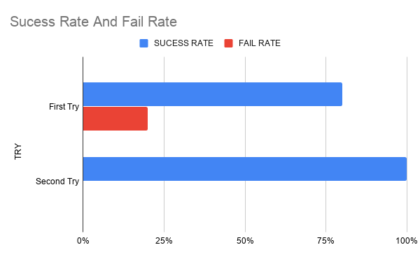

*Level 3*

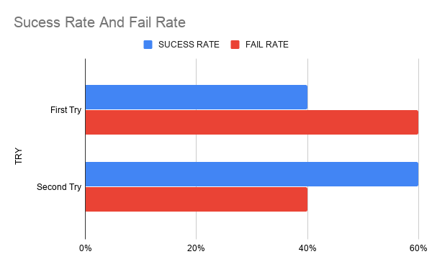

Based on the data above we can see that on level one, 20% of the sample group could not remember the order of the cubes on their first try while 80% of the group could. Then on the harder level, level three 60% of the group couldn't remember the order while they searched for the objects on their first try, while 40% of the group could. The difference between the success rates on the first try could come down to a few factors. One, the users have to not only remember the colour of the shape but also what type of shape it is. Second, they have to multitask by remembering the order and physically looking around the room to find the shapes.

When it comes to second tries the charts show some interesting data. On both levels the success rates increased by 20%. On level One success rates went from 80% to 100% with nobody in the group failing the challenge. On the third level the success rate went from 40% to 60%.

# Project Review and Conclusions

Based on the data gathered in this research, in this instance it does appear that multitasking does in fact have an affect on the users memory. However there was one big limitation to the research and that was time. If the research was to be carried out again a larger user group would be used and more than the first two tries would be recorded for example, the first four tries would be recorded.

# References

|  |  |  |
| --- | --- | --- |
| **Referenced Publication** | **Citation** | **Reference** |
| : [10.3389/fpsyg.2019.02523](https://dx.doi.org/10.3389%2Ffpsyg.2019.02523) | (Zlotnik and Vansintjan, 2019) | Zlotnik. G and Vansintjan. A.(2019).Memory:An Extended Definition. Front Psychol.Frontiers in Psychology. vol 10. |
| IEEE 18th International Conference on Advanced Learning Technologies | (Babu, Krishna, Unnikrishnan, Bhavani, 2018, pp385). | Babu. S, Krishna.S, Unnikrishnan.R, Bhavani.R.(2018).Virtual reality learning environments for vocational education : A comparison study with conventional instructional media on knowledge retention: IEEE 18th International Conference on Advanced Learning Technologies. |
| University of Tartu. | (Kilvits, 2015) | Kilvits. K. (2015). Toolbox for creating virtual reality environments for memory research. University of Tartu. |

# 